SOP - Providing Attendance data for PPC.

This document details the Standard Operating Procedure (SOP) for re-uploading PPC attendance when initial attendance loading by the bot encounters issues. Follow the following steps to successfully upload the attendance.

Step 1 : Log in to the remote desktop server.
To upload data, log in to the remote desktop server having the IP address 192.168.6.157. Use the provided authentication details precisely to ensure a successful and secure connection to the server's resources.
Access Credentials for Remote Desktop Server:
- Username: admin1
- Password: Ig@IbM$2025

Step 2: Log in to the IncuseHR portal.
To access the necessary Excel data, begin by opening your web browser and navigating to the IncuseHR portal. You can reach the login page directly by using the following URL:
- https://intergold.incusehr.com/users/#/login.
Once you have successfully accessed the login page, you will be prompted to enter your credentials. Please use the following information to proceed:
- Username: 001122
- Password: IgReport@1122
After entering these details click on login, you will be able to log in to the IncuseHR system.

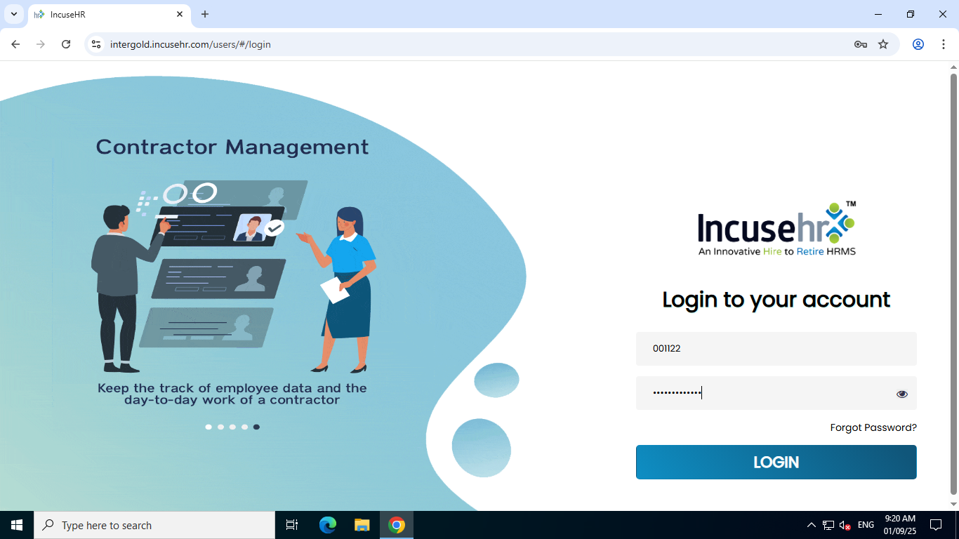

Step 3: Navigation steps to download to attendance excel file.
- Click the 'HR' icon located in the top menu bar.

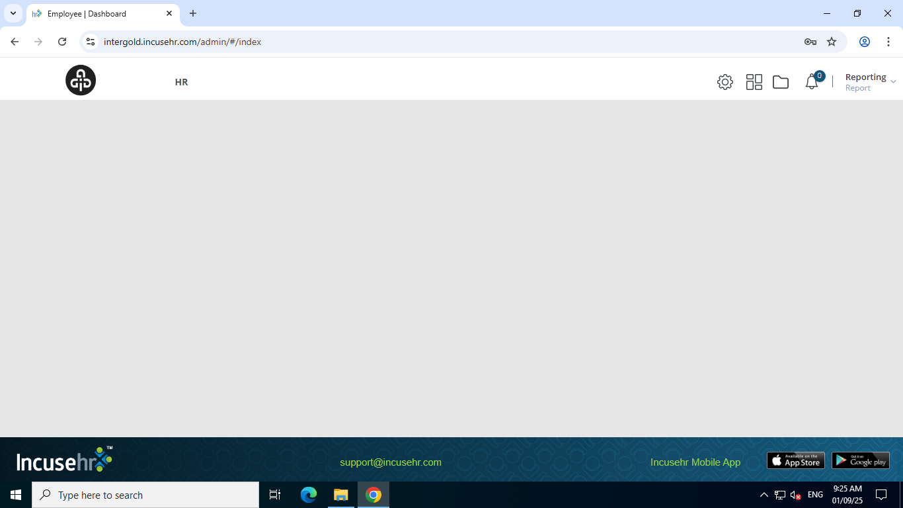
- Access the 'Report Desk' from the top left corner, then select 'PPC Report' from the submenu.
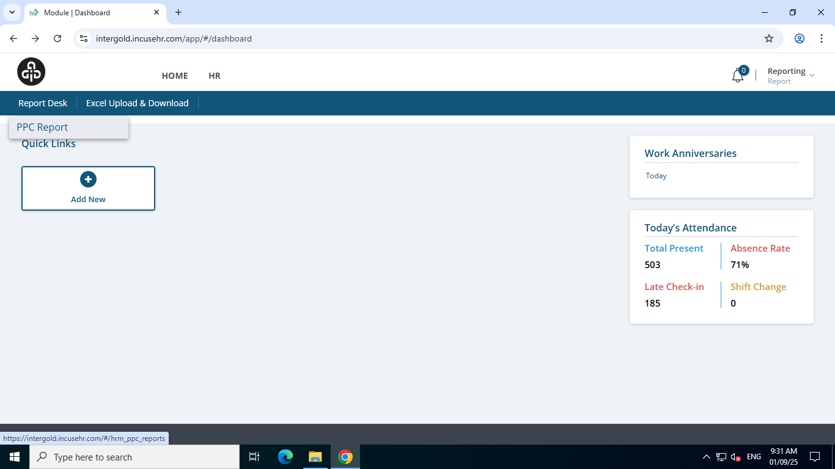
- Navigate to the desired date by clicking the calendar icon on the right-hand side.
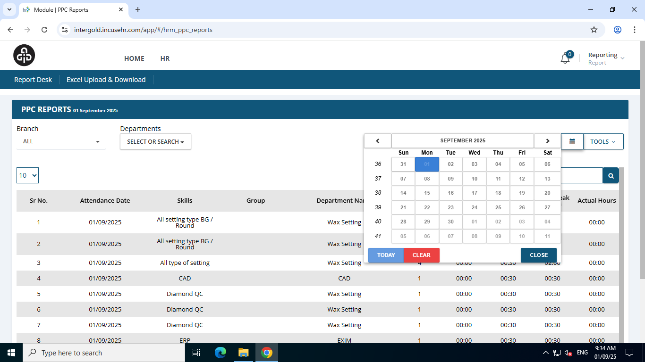

- On the right-hand side you can see a tools menu, navigate to the 'TOOLS' menu and select 'Export to excel' from the submenu.
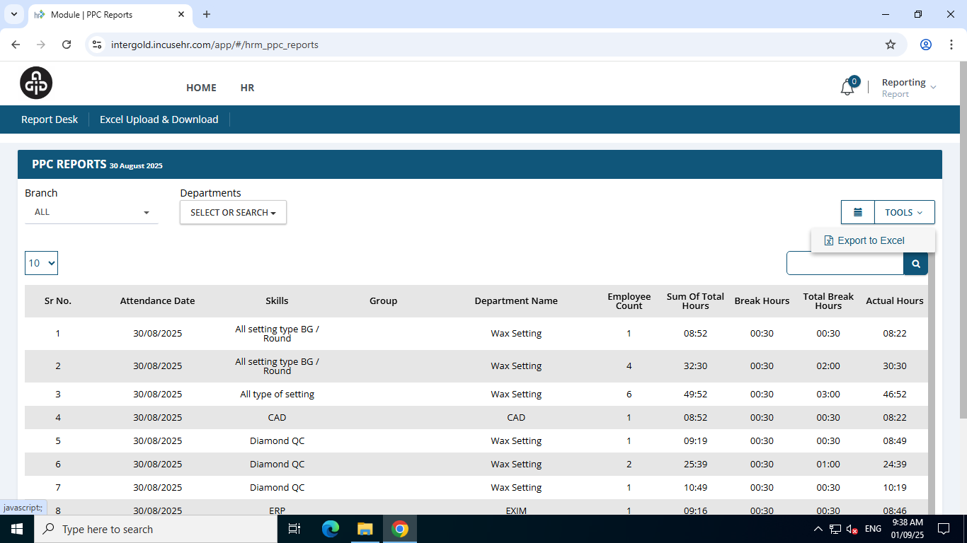
- To download the Excel file, click the link "click here to download the excel" This will direct you to the download page to retrieve the file.
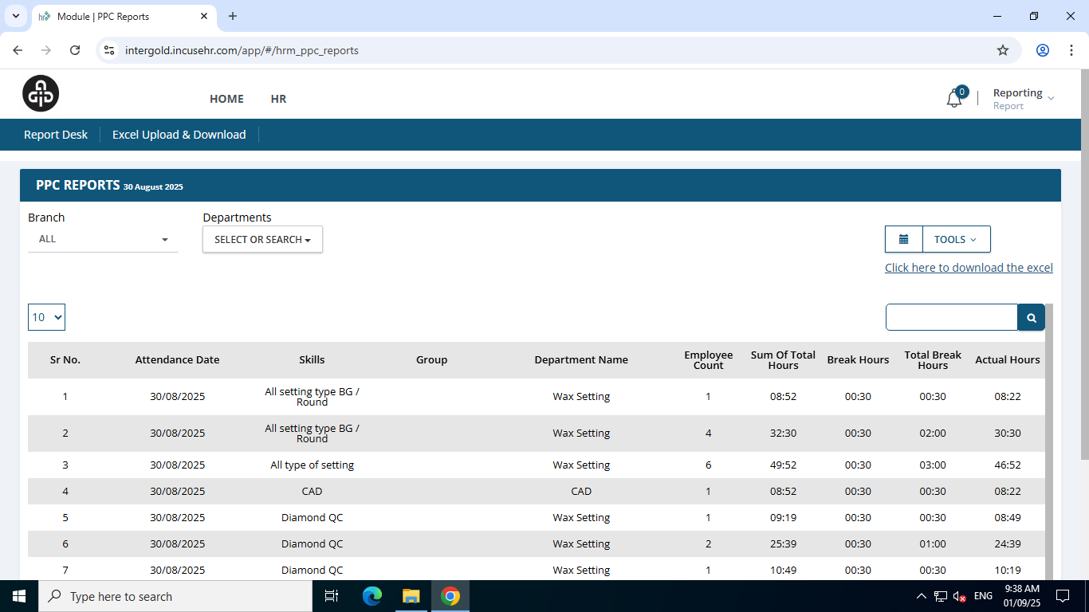
- Wait for the file status to change to "Ready." Once the status is confirmed, click the "Download" button to download the Excel file.
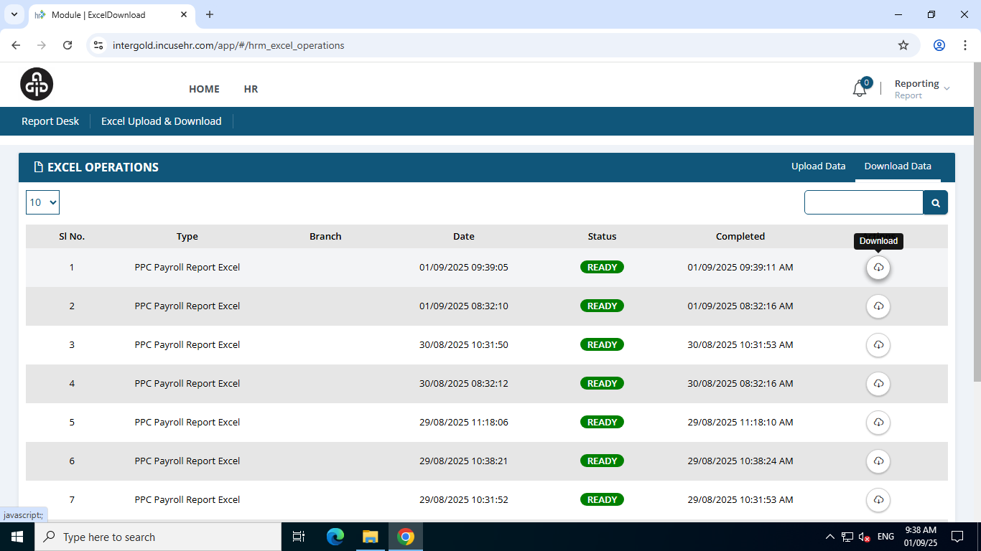

Step 4: Uploading attendance data to database
- Move the downloaded attendance file to D:/Publish/PPC/. Rename the file as follows:
- If it's yesterday's attendance file to be renamed as "PPC Report.xlsx".
- If it’s today's attendance file to be renamed as "PPC Attendance.xlsx".
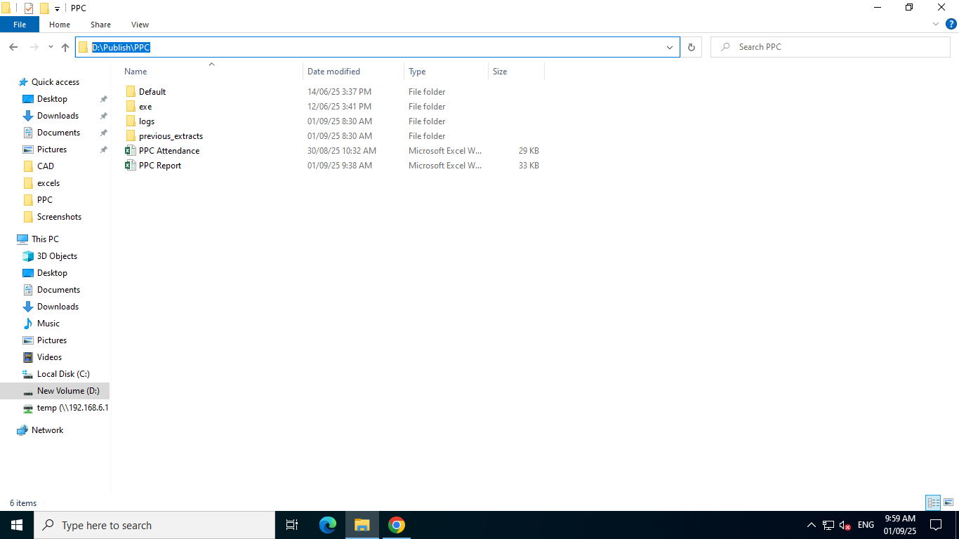

2. To load attendance data into the database, navigate to the folder D:/Publish/PPC/exe.
- In this folder, you will find two executable files:
- To load today's attendance data, double-click ppc_today_attendance_prod.
- To load yesterday's attendance data, double-click ppc_yesterday_attendance_prod.
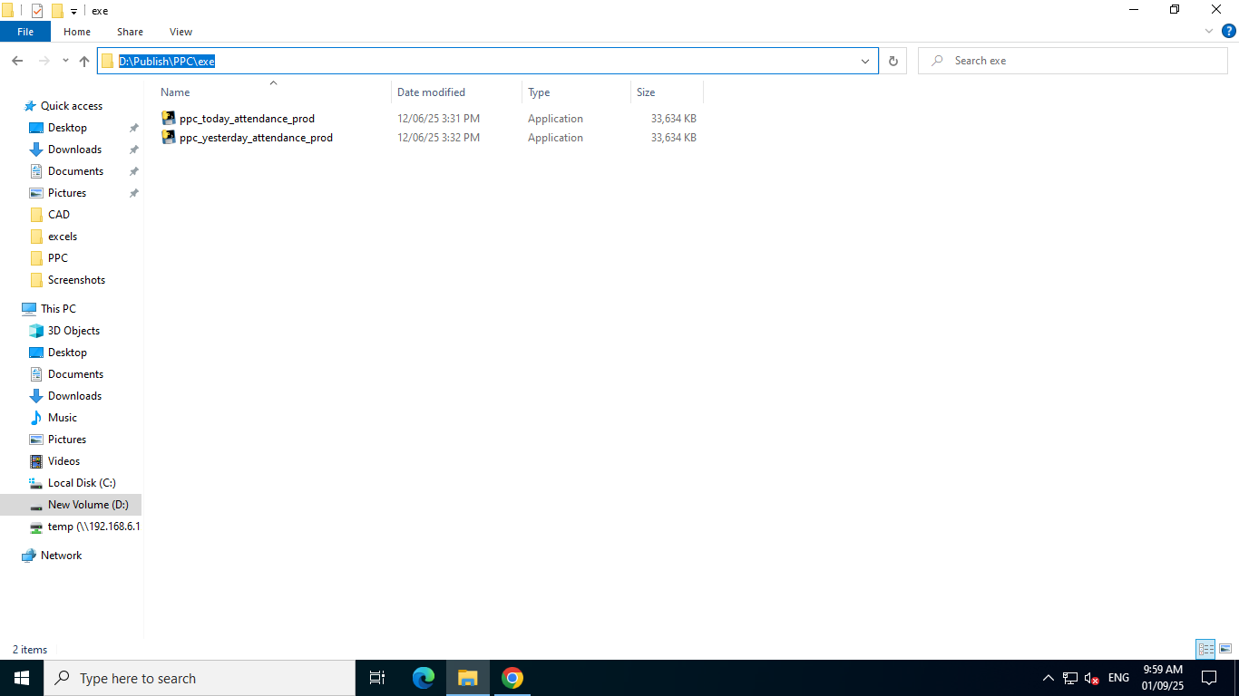
- The executables will then populate the designated database tables with the retrieved attendance data from the Excel.

